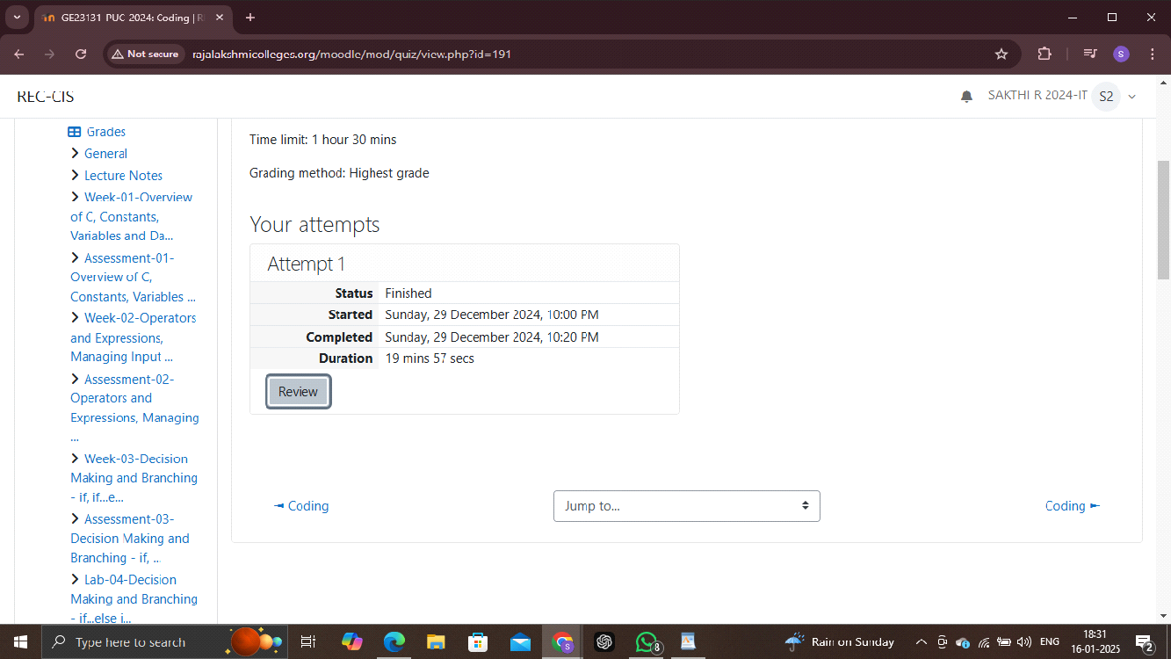

1.Given a string, s, consisting of alphabets and digits, find the frequency of each digit in the given string.

Input Format

The first line contains a string, num which is the given number.

Constraints

1 ≤ len(num) ≤ 1000

All the elements of num are made of English alphabets and digits.

Output Format

Print ten space-separated integers in a single line denoting the frequency of each digit from 0 to 9.

Sample Input 0

a11472o5t6

Sample Output 0

0 2 1 0 1 1 1 1 0 0

Explanation 0

In the given string:

· 1 occurs two times.

· 2, 4, 5, 6 and 7 occur one time each.

The remaining digits 0, 3, 8 and 9 don't occur at all

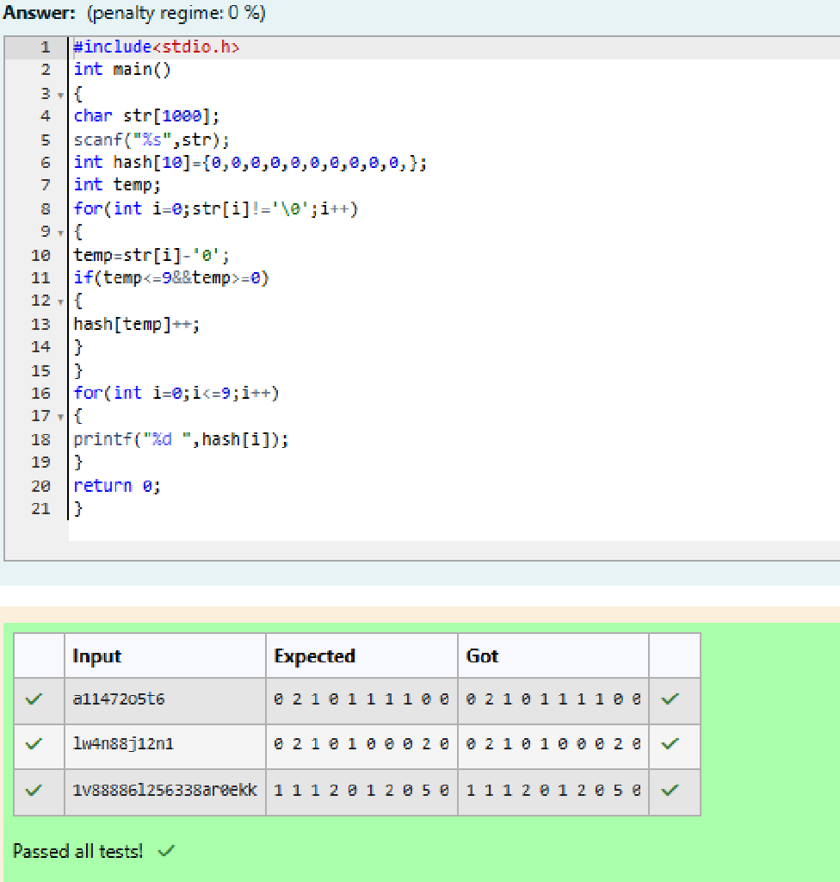

2.Today, Monk went for a walk in a garden. There are many trees in the garden and each tree has an English alphabet on it. While Monk was walking, he noticed that all trees with vowels on it are not in good state. He decided to take care of them. So, he asked you to tell him the count of such trees in the garden.

Note: The following letters are vowels: 'A', 'E', 'I', 'O', 'U', 'a', 'e', 'i', 'o' and 'u'.

Input:

The first line consists of an integer T denoting the number of test cases.

Each test case consists of only one string, each character of string denoting the alphabet (may be lowercase or uppercase) on a tree in the garden.

Output:

For each test case, print the count in a new line.

Constraints:

1 ≤ T ≤ 10

1 ≤ length of string ≤ 105

SAMPLE INPUT

2

nBBZLaosnm

JHkIsnZtTL

SAMPLE OUTPUT

2

1

Explanation

In test case 1, a and o are the only vowels. So, count=2

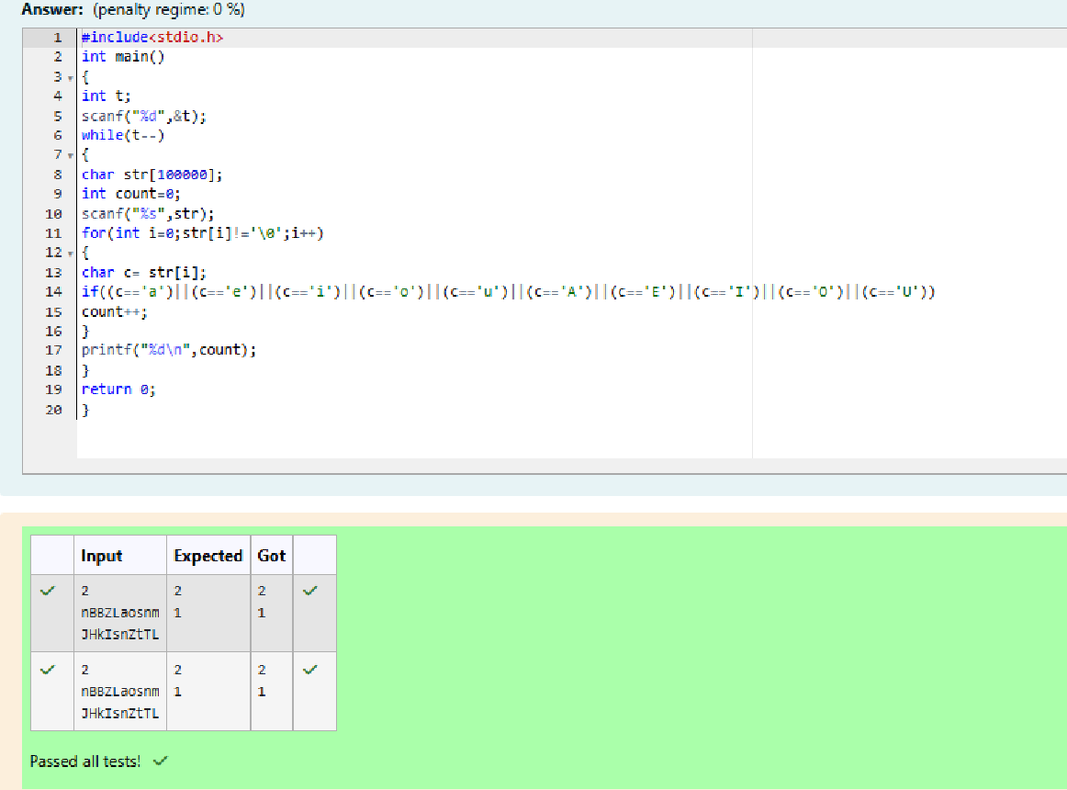

3.Given a sentence, s, print each word of the sentence in a new line.

Input Format

The first and only line contains a sentence, s.

Constraints

1 ≤ len(s) ≤ 1000

Output Format

Print each word of the sentence in a new line.

Sample Input 0

This is C

Sample Output 0

This

is

C

Explanation 0

In the given string, there are three words ["This", "is", "C"]. We have to print each of these words in a new line

